|  |  |
| --- | --- |
| **Product Name** | Applied Degree in Software Engineering (BDSE) |
| **Qualification Name** | Applied Degree in Software Engineering |
| **Product Name** | Front End Web Development |
| **Module Name (BDSE)** | BDSE-Front End Web Development |



|  |  |  |  |  |
| --- | --- | --- | --- | --- |
| **LearnerName** | |  |  | **Assessor Name** |
| Syavira Rizki A. | |  | Ms. Ayesha Shariff | |
|  |  |  | | |

|  |  |  |
| --- | --- | --- |
| **Date Issued** | **Completion Date** | **Submitted On** |
| February 10, 2023 | Feb 17, 2023 | Feb 23,2023 |

|  |  |
| --- | --- |
| **Project Title** | ABC Learning Center Website |

|  |
| --- |
| **Learner Declaration** |
| I certify that the work submitted for this assignment is my own and research sources are fully acknowledged.    Student Signature Date: 23th-feb-2023 |

Table of contents :

**Scenario &**

**purpose** ................................................................................................................................................ **3**

**InformationArchitecture**....................................................................................................................... 4

definition.................................................................................................................................................4

characteristic......................................................................................................................................... 4 advantages.......................................................................................................................................... 4-5 **explain each levels & blocks and means** ................................................................................. 6-7 **picture of information**

**architecture**…………………………………………………………………………………………………………………………7 **wireframes**…………………………………………………………………………………………………………………………..8 definition……………………………………………………………………………………………………………………………..8 characteristic………………………………………………………………………………………………………………………..8 advantages&disadvantages……………………………………………………………………………………………….8-9

**explanation about each**

**wireframe**……………………………………………………………………………………………………………………..10-16

**Storyboard**………………………………………………………………………………………………………………………….17

Definition……………………………………………………………………………………………………………………………17

Characteristic……………………………………………………………………………………………………………………..17

Advantages

&disadvantages……………………………………………………………………………………………………….……17-18

**Picture of mind mapping storyboard**………………………………………………………………………………..18

Explanation………………………………………………………………………………………………………………………..19

**Implementation**………………………………………………………………………………………………………………..20

**All pages website**…………………………………………………………………………………………………….…...21-35

Testing & validation………………………………………………………………………………………………………………..…..36-40

**Chapter 01**

Scenario and Purpose



Chapter 02

**Information Architecture**

Definition:

Information architecture is the science and art of labeling and organizing web pages for ease of use. It also refers to how information is organized on a website, mobile app, software, or other product. With information architecture, view the entire product at once, with functions indicated by directional arrows and hierarchical levels

Characteristic :

Information Architecture (IA), like a blueprint, is a visual representation of a product's infrastructure, functionality, and hierarchy. The level of detail is up to the designer, so AI can also include navigation, app functionality and behavior, content, and flow. There is no limit to the size or shape of the AI; however, it should include the general structure of the product so that anyone (theoretically) can read and understand how the product works.

Advantages of IA:

Better scope of the project

The information architecture acts as a blueprint for mapping patterns and interaction paths. Custom AI design brings better clarity to the project. A better understanding of project scope allows developers to provide more accurate estimates to project managers, product owners, and customers. One of the best benefits of information architecture, it exposes the depth of UX and the number of decision layers and levels of hierarchy in the product. This gives a full idea of how many clicks or screens it takes to complete a task. Fix content gaps:

IA is all about organizing content in a logical way, and the process requires the developer to consider what might be missing and what fits where. Custom information architecture identifies areas of content clustering, decision bottlenecks, visual controls, unused areas, recursive or duplicate paths. It will also separate necessary content from unnecessary content, especially for a website that currently has a lot of content.

Product overview inside and out:

IA is the foundation for any website and it comes with marketing automation features. The principles of artificial intelligence must be fully applied to marketing initiatives such as blogs and landing pages. The AI process can also help internal marketers, content owners, and stakeholders grasp the basics and understand website functionality. An information architecture acts as a model for mapping interaction paths. Choosing an information architecture service for any website makes perfect sense.

Information architecture is a great way to get the big picture. The overview helps a lot to manage and operate production later. Choosing the best information architecture service has many advantages. Choosing a better information architecture service has a greater influence on the quality of the software product.

 Info arch of the given scenario:

|  |
| --- |
| \n……. |
| Common content : |
| Header |
| Navigation |
| Footer |
| 1. Homepage |
| 2. Profile |
| 3. Contact us page |
| 4. Course detail page (2 page) |
| 5. Course schedule page (2 page) |
| 6. Sitemap page |
| 7. Privacy policy page |

Explain what each levels and blocks of the IA means ( 2 – 3 lines each block/level ) :

Logo : logo of ABC Learning Center

Homepage : introduction of page Abc Learning Center site ( typically serving as a table contents as a table of contents for the site nav bar & search bar : to make easy to searching & accessing of the page they want.

Profile : defined as a professional introduction that aims to attract the attention of readers and briefly inform about the company.

Contact us : provide guidance for existing customers and offers an overview of my brand for new visitors. They people can contact through google site, email, whatsapp, twitter, instagram, and Etc.

Course :

Course page : all about course list that will be added and then exposure to the material to be learned :

- Course List :

* Programming in Java : java introduction, java flow control, java arrays, java OOP, and java execution handling, etc.
* Programming In.Net : #c,#f, visual basic, etc.
* HTML : HTML introduction, HTML Elements, HTML structures, etc.
* Microsoft : Microsoft Office,Microsoft Word, Microsoft excel,etc.

About detailed course page :

Videos : about the lessons.

Link : people who need to register. If them click to the link, it will go to the register form

Books / template of lessons or material with the click button, to go back to course list page.

Calendar : make easy people to see when the course opened.

Help : it will go to help page, and make the solutions who people get confused.

Schedule :

About schedule : to inform students/ people to join and attend the class. Such as lesson,about, and other materials with the date to exam and finish the course.

Detailed about schedule : more detailed to class session and exam session.

Sitemap :

Sitemap page : to help search engines find, crawl and index all of my site’s content.

Privacy policy :

Privacy policy page : statements that explains In simple language how an organization or agency handles my personal/company personal information.

Navigation : specific destination.

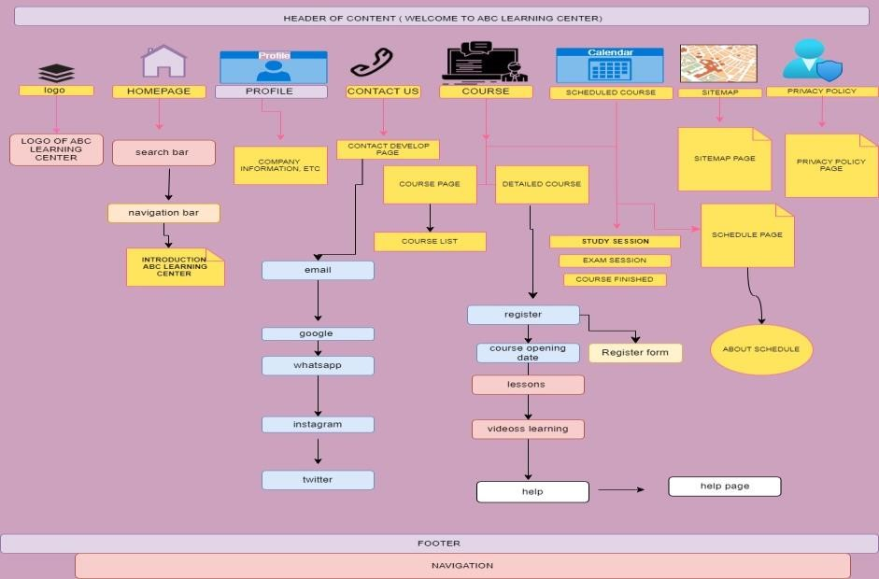

**Chapter 03**

**Wireframes**

Definition:

A wireframe is a two-dimensional illustration of the look and feel of a page with a particular focus on space allocation and content prioritization, available features, and expected behaviors. For these reasons, wireframes usually don't include any styles, colors, or graphics. Wireframes also help establish relationships between different designs on a web page.

Wireframes are often used to lay out the content and functionality of a page taking into account the user's needs and journey.

Characteristic :

Wireframes focus on:

* Range of available functions
* Relative priorities of information and functionality
* Rules for the display of certain types of information
* Effects of different scenarios on the screen

A web site's wireframe connects the underlying conceptual structure or information architecture to the site's surface or visual design. Wireframes help establish the functionality and relationship between different screen styles on a web page. An iterative process, wireframing is an effective way to quickly prototype pages, while also measuring the reality of design ideas. Wireframing usually begins between "high-level structural work, like flowcharts or sitemaps, and screen design." In the process of creating a website, wireframing is where thought becomes tangible.

Advantages:

* Provides an original image that can be used for review with customers.

*Users may also consider this as an early feedback mechanism for prototype usability testing. * Not only are wireframes easier to modify than conceptual designs, but once approved by clients and users, they give the designer confidence.

Disadvantages:

*The wireframes do not include any design or any technical involvement, it is not always easy for the client to understand the concept.

* The designer will also need to translate the wireframes into a design, so communication to support the wireframe is often needed to explain why page elements are positioned as they are.
* Additionally, as content is added, there may be too much content to fit in the wireframe layout at first, so designers and writers will need to work closely together to fit the content. that content.

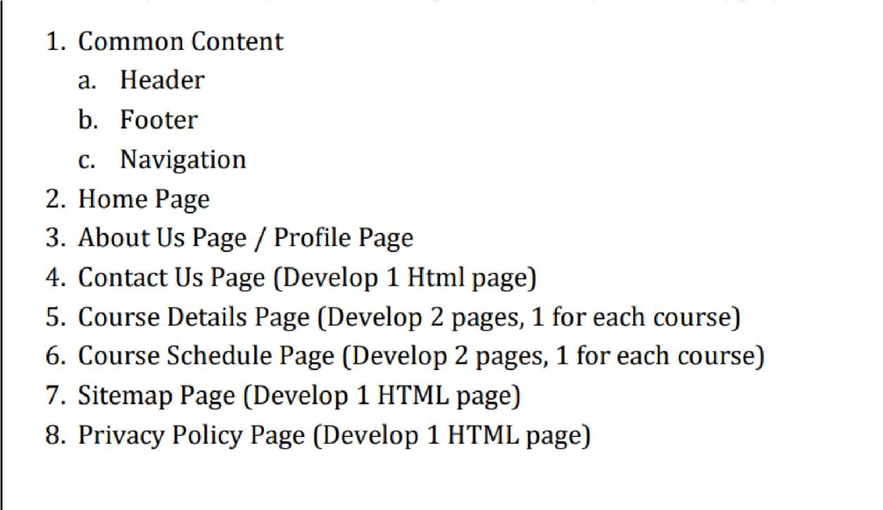

HOMEPAGE :

Header /banner : “WELCOME TO ABC LEARNING CENTER!”



Logo of ABC Learning Center

Navigation bar

Menu bar : homepage,profile,contact us,course,schedule,sitemap,privacy policy

Videos about ABC Learning Center



Introduction of ABC Learning Center

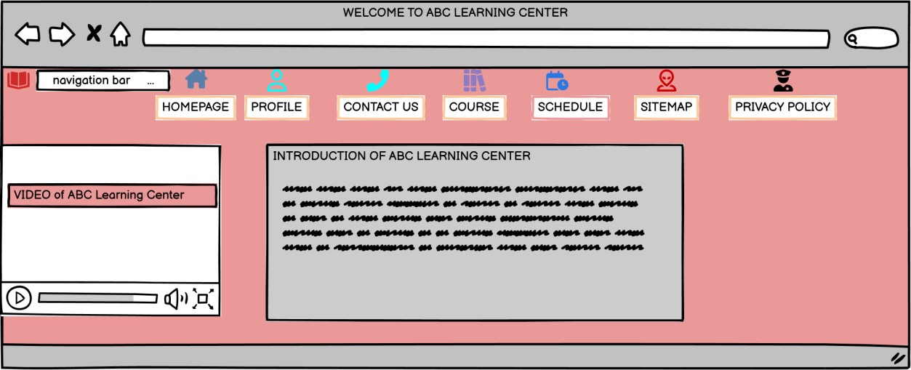

PROFILE PAGE :

About the profile company



Images of company ABC Learning Center

And the last one is other pictures about the Learning Center

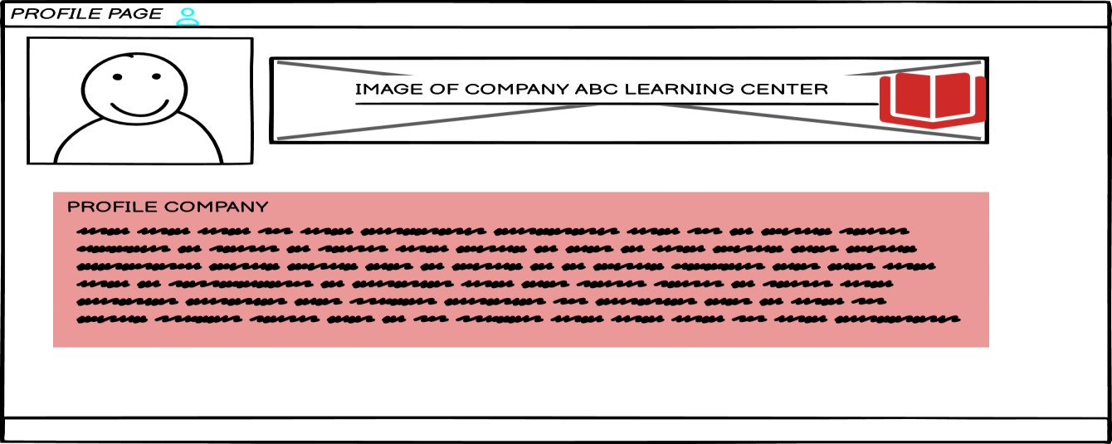

**CONTACT US PAGE :**

More explanation about contact us



Social media company advertisment

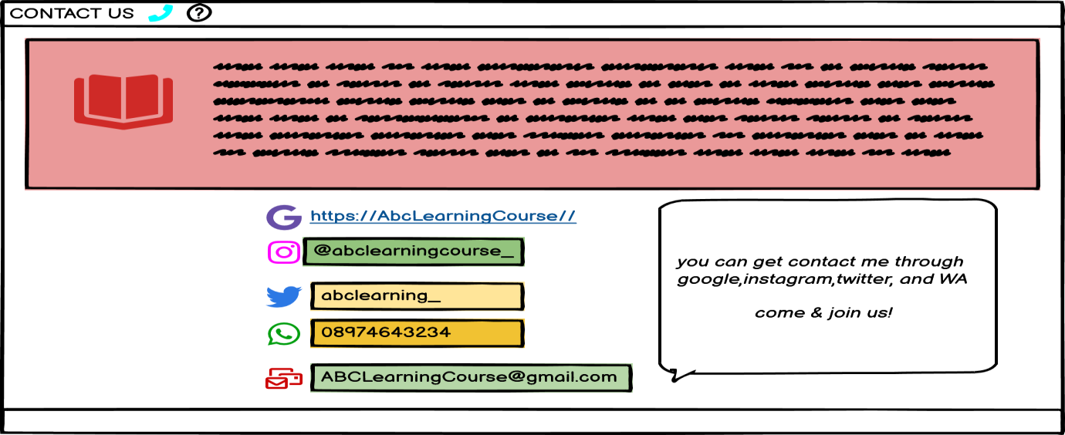

**COURSE PAGE (1) :**

Videos learning/about the lessons,



Links of register

Lessons and others

Courses opening date as calendar

Help for courses help

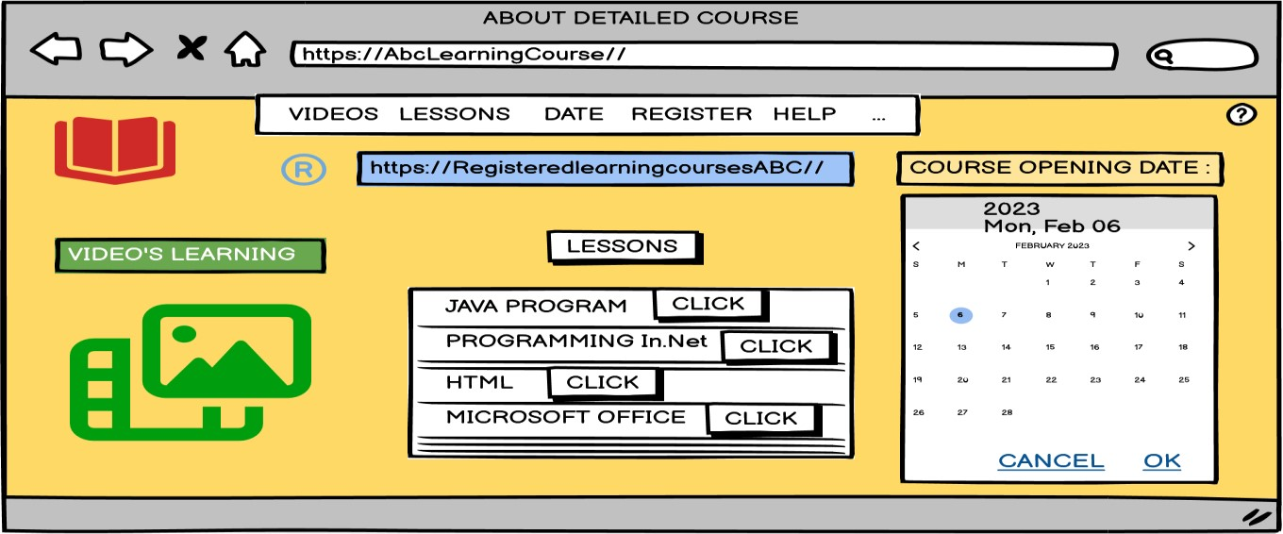

**REGISTER FORM :**

* click on sign in
* fill the name column
* and then fill the age
* email
* confirm password and click
* you already registered

Button for next page (CLICK FOR THE COURSE PAGE)

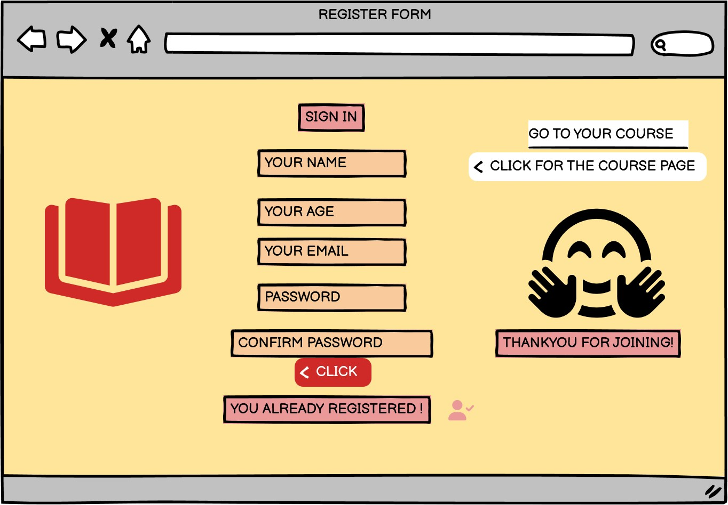

**COURSE PAGE (2) :**

**ALL ABOUT COURSE AVAILABLE :**

PROGRAMMING IN JAVA, PROGRAMMING In.Net,HTML, MICROSOFT OFFICE.

**SCHEDULE PAGE (1)**

**:**

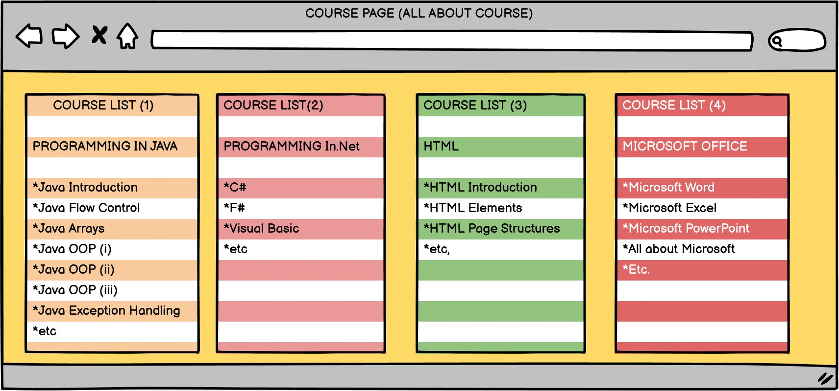

Lessons,about the lesson/materials,schedule for each month, exam session and date.

And the date of course finished.

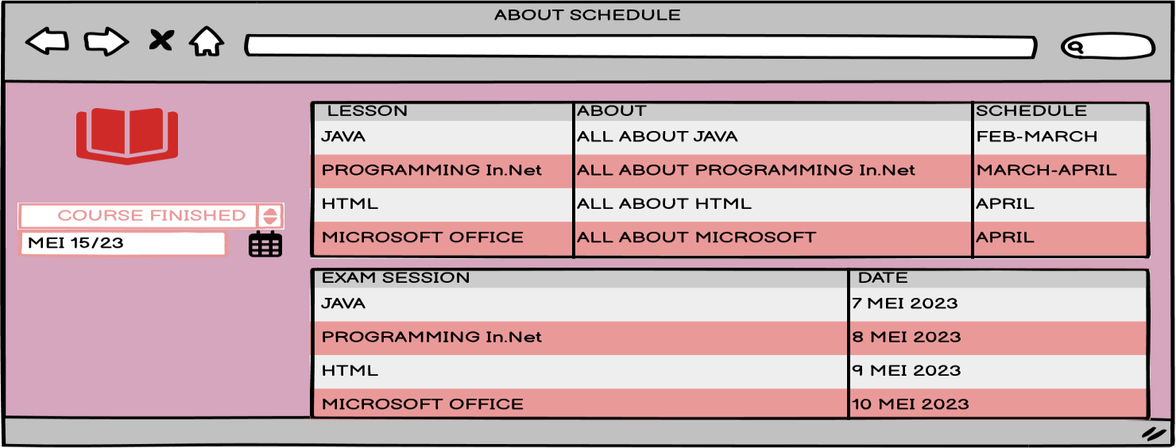

SCHEDULE PAGE (2) :

Java lessons schedule planning : 4-27/28 feb, until march 1-7

Programming In.Net Schedule planning : march (10-31 march)

Microsoft lessons schedule planning : april (20-30 april)

Html lessons schedule planning : april (1-18 april)

Exam session planning : mei 7-10

Course finished planning : 15

th

mei 2023

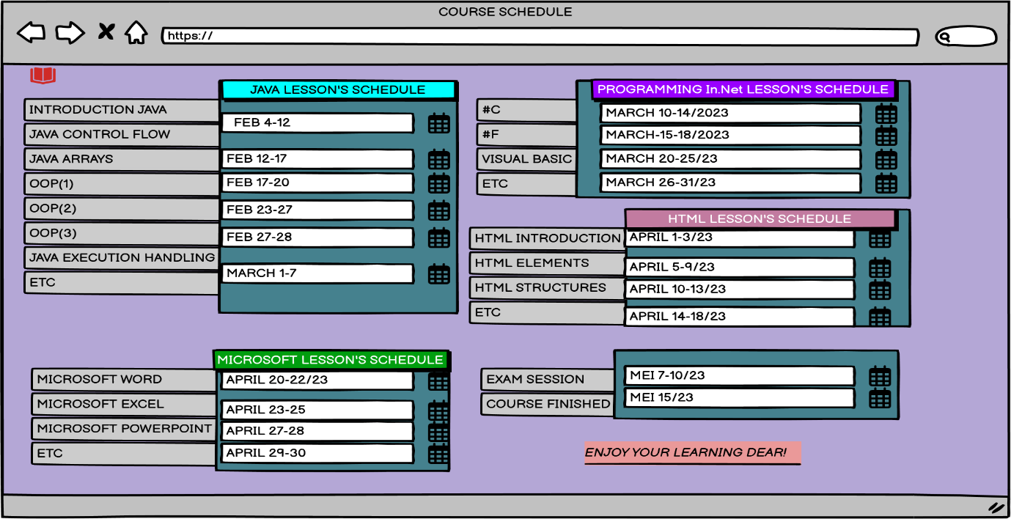

**SITEMAP PAGE (JUST EXAMPLE) :**

|  |  |  |
| --- | --- | --- |
| Homepage | Course page | Detailed course |
| Profile | Schedule page | Detailed schedule |
| Contac us | registerform | sitemap |
| course | privacy policy | navigation |

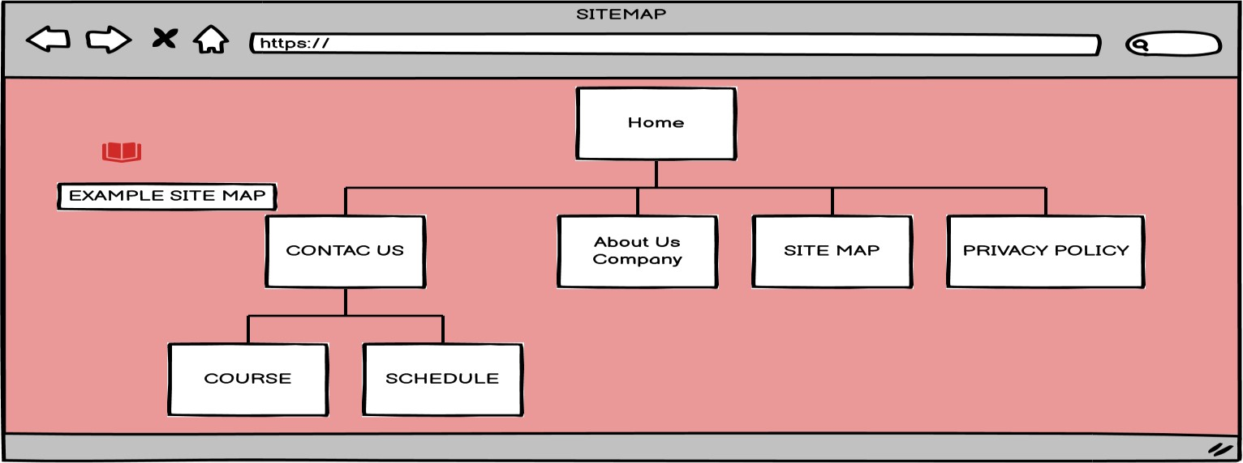

**PRIVACY POLICY PAGE :**

✓

All about privacy policy.

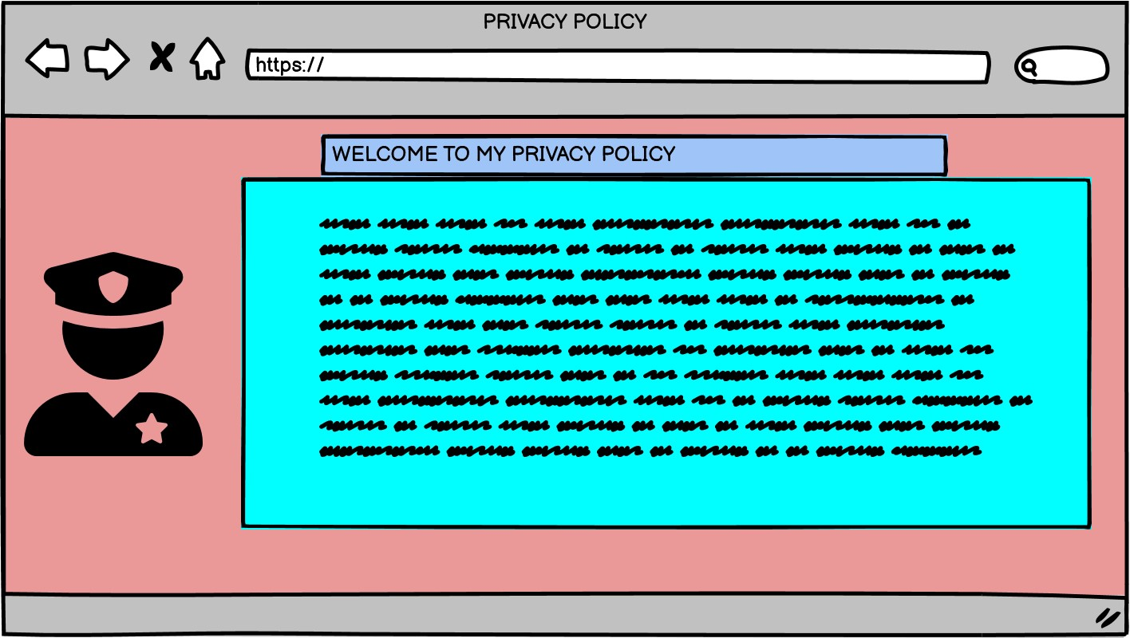

**HELP PAGE :**



he

lp :



link to back into profile page



link to back contac us



link to back course

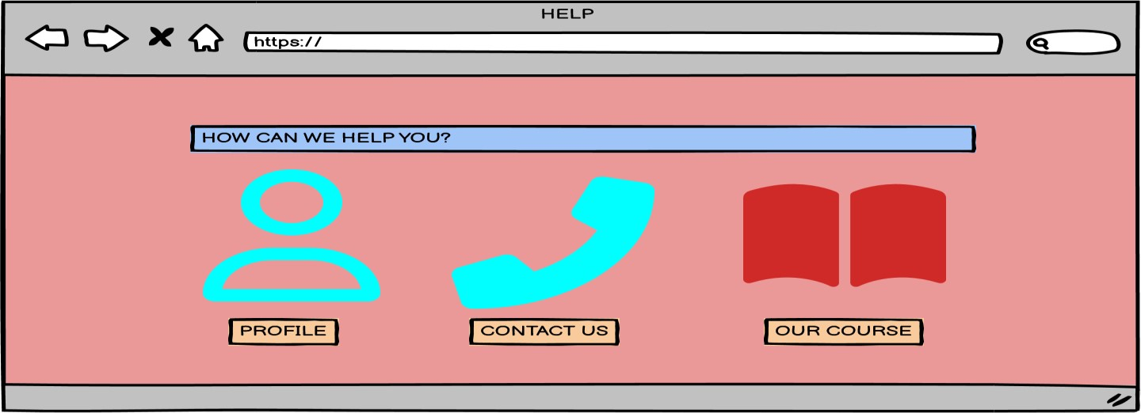

**EXAMPLE OF NAVIGATION BOTTOM PART :**



Images of location



Link map



logo

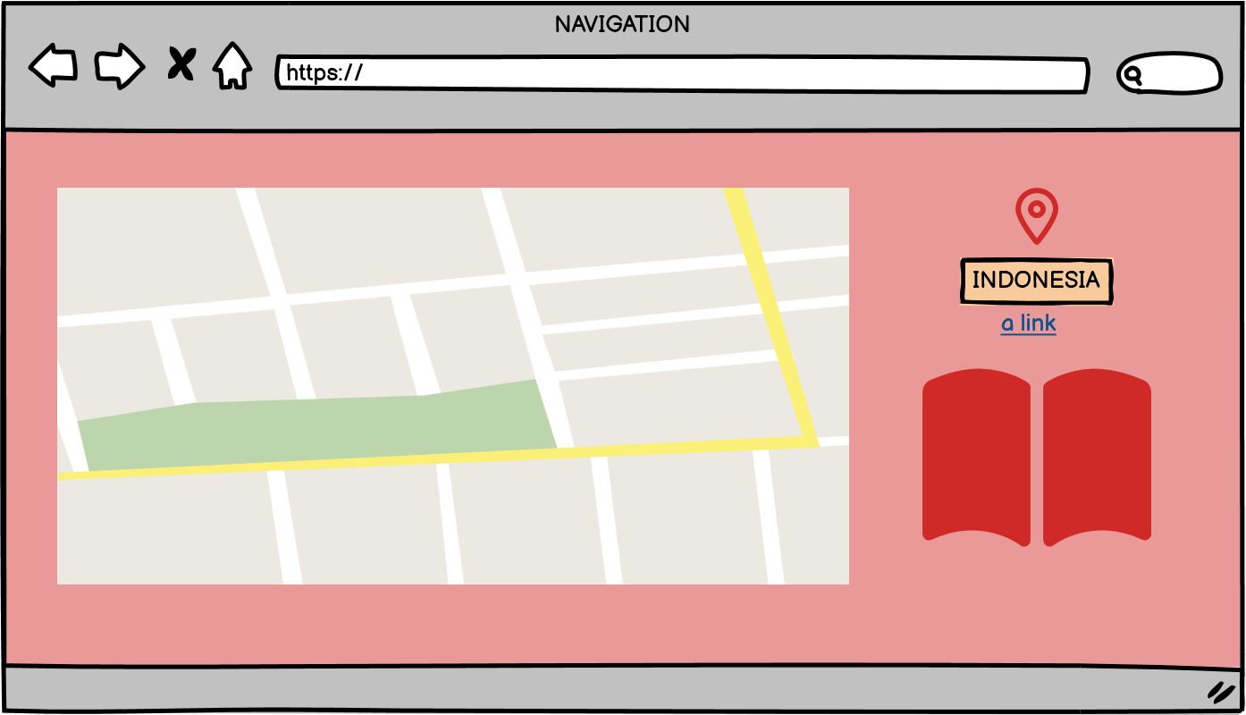

**Chapter 04** **Storyboarding**

Definition :

A storyboard is a graphical representation of how your video unfolds, shot by shot. It's made up of a number of squares with illustrations or pictures that represent each shot, with notes about what's going on in the scene and what's said in the script in that shot.

The main characteristics of storyboards are:

* Visualize the narrative.
* Focus on story and timing on multiple keyframes (very important in animation).
* Define the specifications:

description of motion, camera, light, etc.

Advantages :

It gives you a clear idea of the photos you want.



It gives you more time to film and edit.

This gives you an idea of the timing of each shot.

It helps you during the day.

It helps keep your team organized. This means that you will not waste time filming and therefore will not drain the battery.

It helps you plan your story in advance during the editing process.



It gives you an idea of what you want to do – it is a planning document, not a law so you can easily change your ideas.

Disadvantages:

It is usually not very detailed.



Some will say it takes time - you can start filming instead of wasting time writing storyboards.

It can be limited at times.



The end result of the storyboard is not always pretty.

MIND MAPPING STORYBOARDING

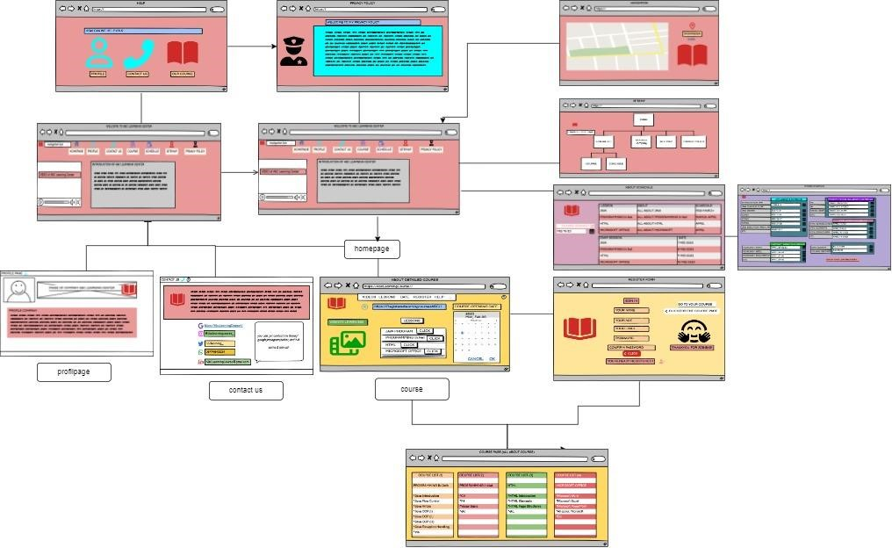

Sequence :

homepage view for the illustrated about site home page : logo banner/header : “welcome to ABC Learning Center” menu bar such as : homepage itself, profile,contact us, course,schedule,sitemap, and privacy policy.  introduction about learning center, videos, and etc.



* if click the profile : will go to profile page about companys, pictures, etc
* if clicking the contac us : will go to the contac us page : more detailed about contac companys,social media, and advertisement
* if clicking the course it is connected and will go to course page & detailed course :
* about detailed course : it is about register link,lessons,help, course opening date, etc.
  + if they click the link of register, they will go to the register form page and then they will instructed to fill the each column and getting the account.
  + If they click help : it will go to the help page : and we helping them to click link button to back into profile,contact,and course to get solutions.

* + course page is about course list, namely java programming,In.Net programming,html,and Microsoft office.

* If they click the schedule it will be connected to course schedule page & about schedule page :
  + - About schedule such as a lessons, materials, and date who people must attend the this class, exam schedule, also the date of course finished.
    - Course schedule page :

It is about more detailed date & materials which is learn day by day.

* If they click the sitemap : it will go to the sitemap page which is contains a folder that can make it easier for visitor to view the web /site /page they want.
* If they click the privacy policy it will be connected to the privacy policy page, and the visitors see all about these page.
* For the navigation it will be bottom of footer : it is about detail location.

**Chapter-5**

**Implementation**

­­­­ In order to complete this project, we made use of the browsers Chrome, Edge, and Firefox as well as a piece of software known as Visual Code or VS Code. We need the extensions in visual code to run the code correctly. However, prior to all of this, I used a different software called balsamiq to create the Information Architecture, Wireframes, and Storyboard.

This Balsamiq is really helpful because it has so many features. We used Visual Code to create HTML, CSS, JavaScript, and booststrap code, and we had to add extensions to make the code or project run properly.

We used HTML, CSS, JavaScript, and bootstrap in this project. As we probably are aware, the three dialects complete one another, however we really can utilize html without CSS, for this situation we need to appropriately run it.

We use a programming language that uses HTML, CSS, and Javascript for the code. On some pages, we also use bootstraps.

HTML is mostly used to make pages, CSS is used to design each page, and Javascript and bootstrap can be used to quickly make responsive websites.

Here is my GitHub link:

<https://syavirarizkiariani.github.io/abclearningcenter/>

Hardware and Software requirements:

|  |  |
| --- | --- |
| **Hardware** | **Software** |
| PC/Laptop | Visual Code |
|  | Balsamiq |
|  |  |

Without all of the Hardware and Software we’re not sure we can run or making this project, so this requirement is really important. You will need a device such as a computer or server to run the software and execute your code.

1. Common Content

a. Header



in this header containing a a logo, homepage,profile,contact us for the communication if the person get issues, then course details such as java lessons,html lessons,Microsoft office, and programming In.Net. for the schedule menu such as about schedule and details schedules, sitemap,privacy policy,register for the person want to register, login for login into peoples account. The last one is help.

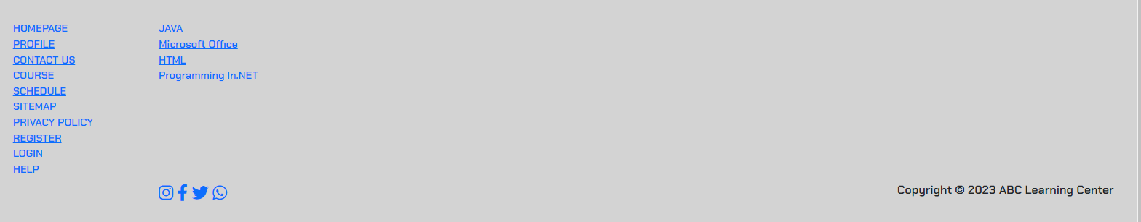b. Footer

in the footer there is a homepage,profile,contac us,course,schedule,sitemap, privacy policy, register, and login accounts to access the site.furthermore for all courses. Also copyright (the exclusive legal).

c. Navigation

in the navigation there is also a home, profile, dropdown course details which contains some of the most popular courses, dropdowns schedule menus,sitemap.privacy police,register,login, and help.

2. Home Page

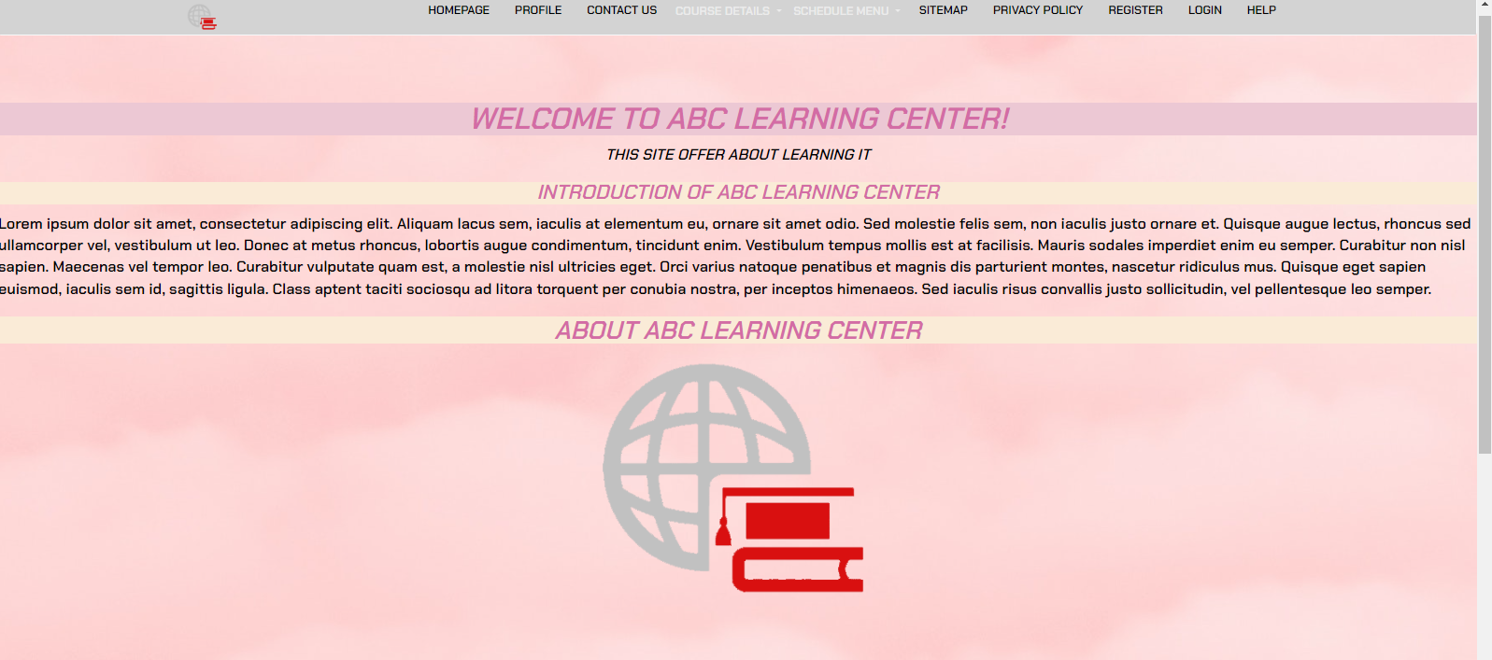

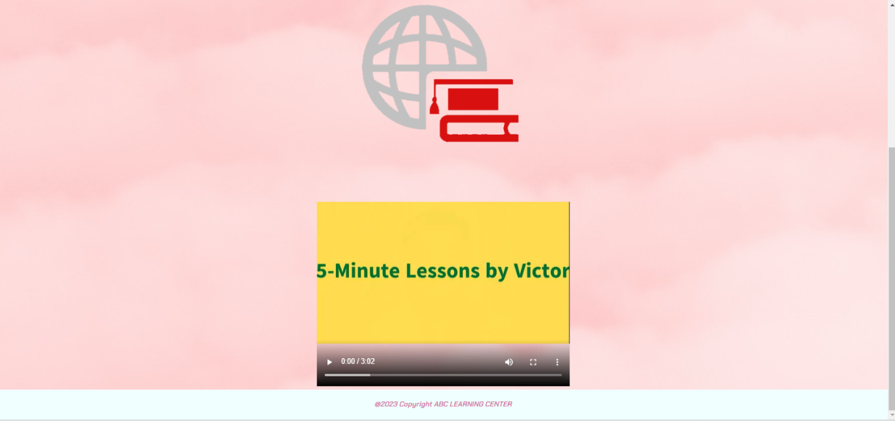

This home page contains some of the information on the website, in the first section we will present it with the “WELCOME TO ABC LEARNING CENTER!” , then in the next section we will present the introduction of abc learning site itself and offering learning IT, in the third section the user will be presented logos of companies of ABC Learning Center &videos.

3. About Us Page / Profile Page

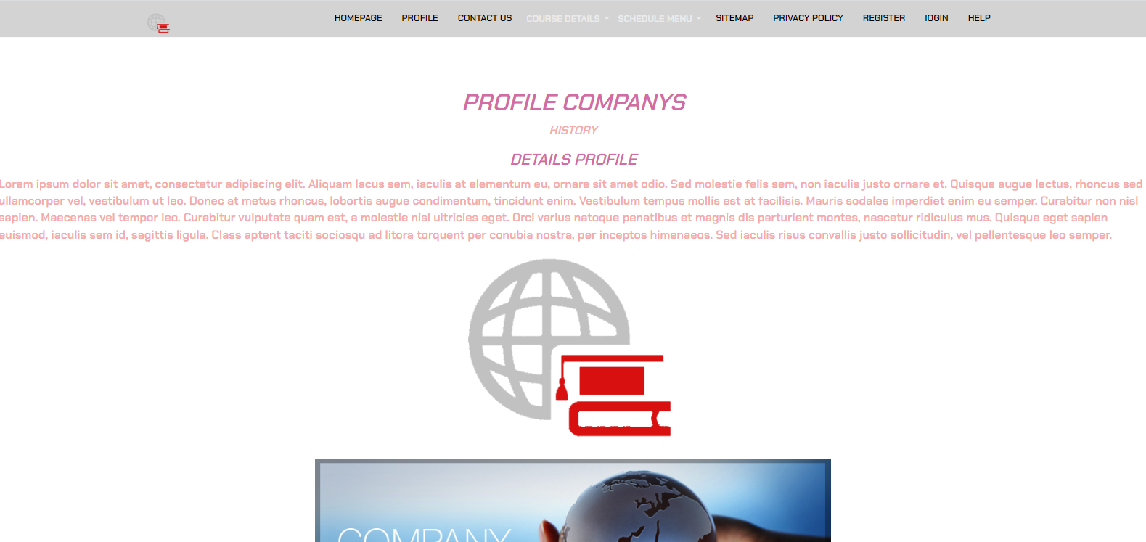



This profile page contains detailed information about profile companys ABC Learning Center itself.History and anything else about company.

4. Contact Us Page (Develop 1 Html page)

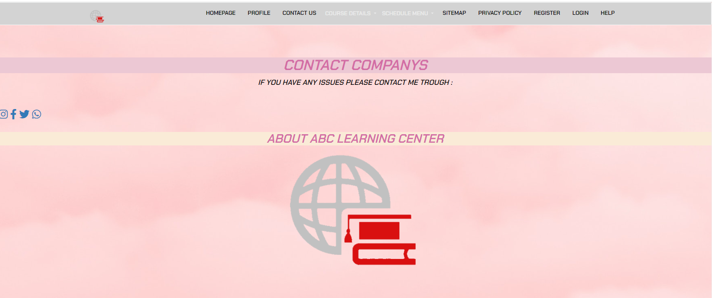

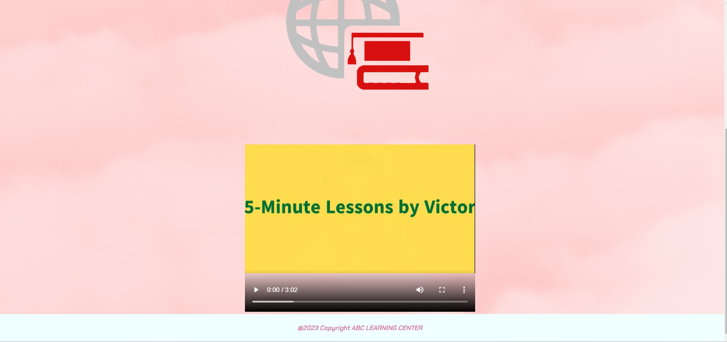

the contact us contains the headline is navigation bar. Also contact of companys itself if they need some help or something they need.

5. 4 Course Details Page ( 1 for each course)

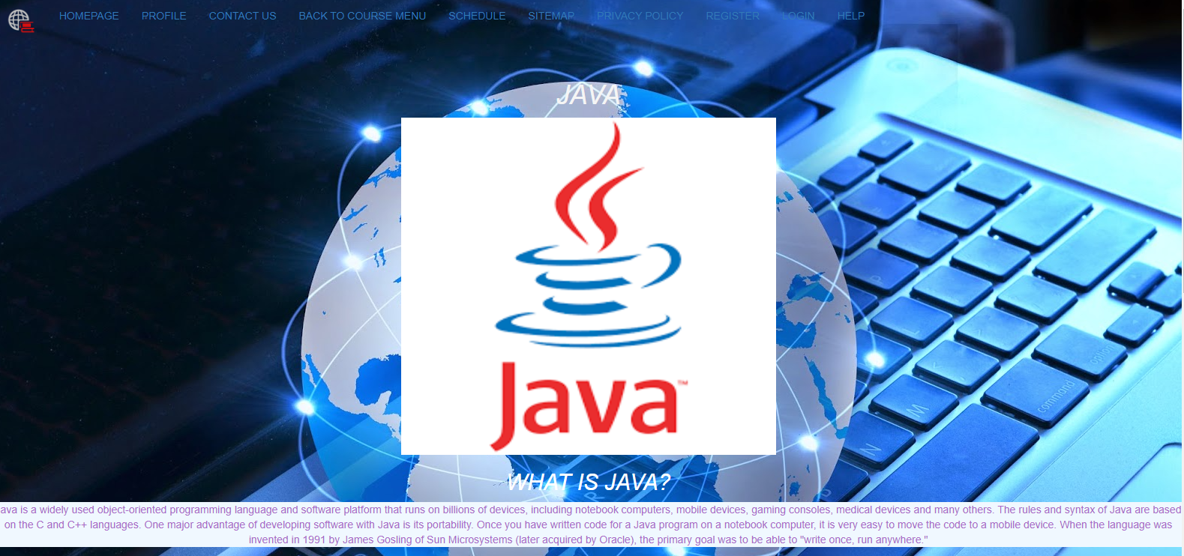

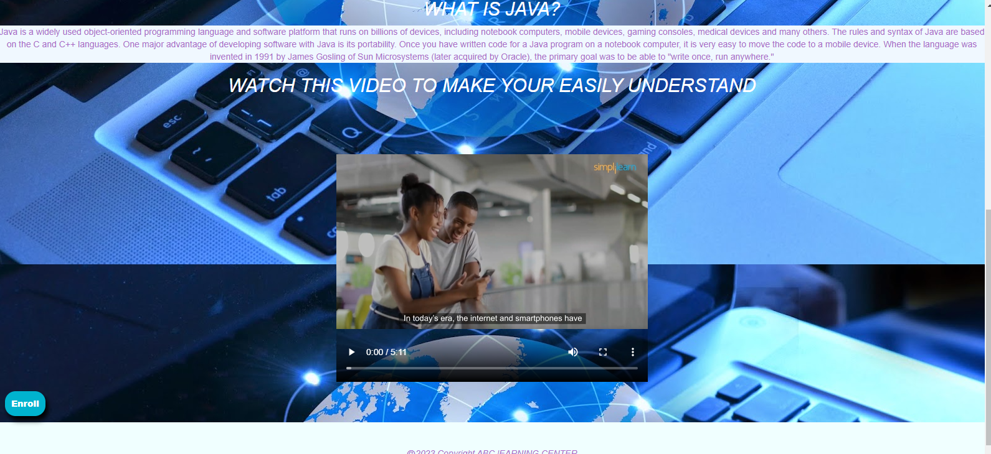

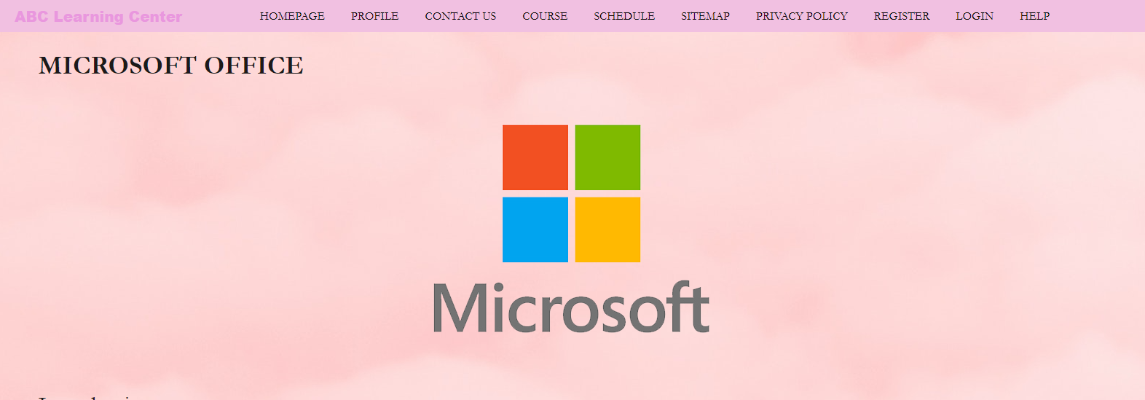

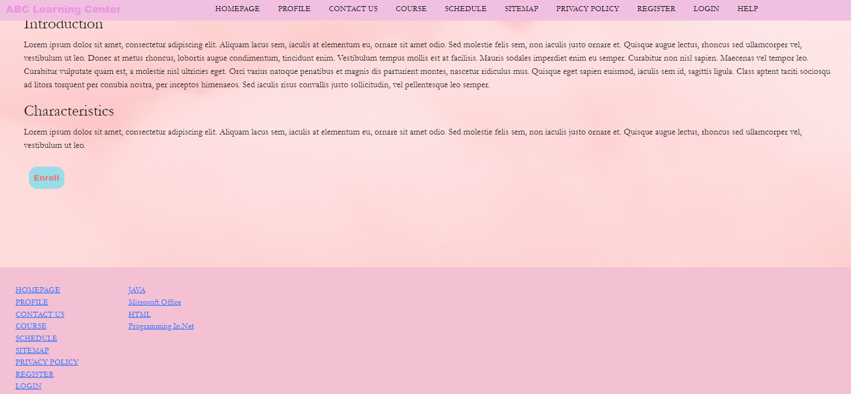

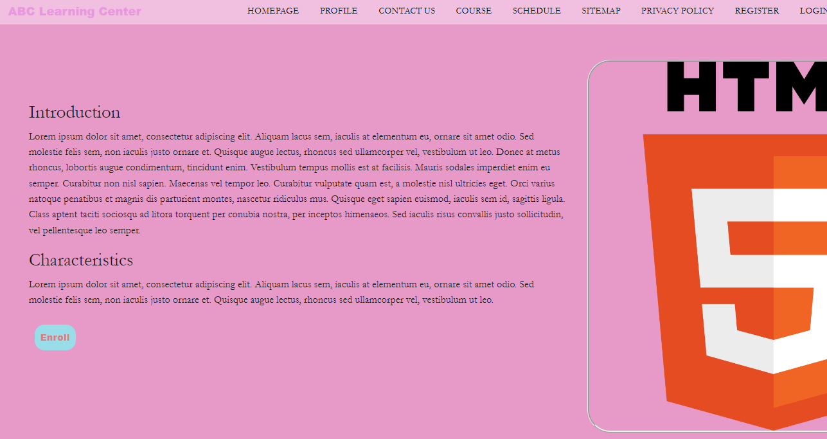

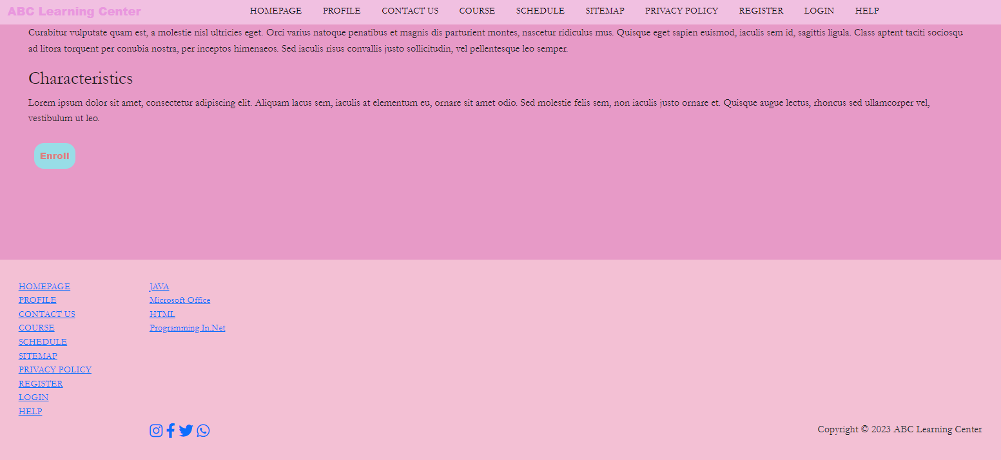

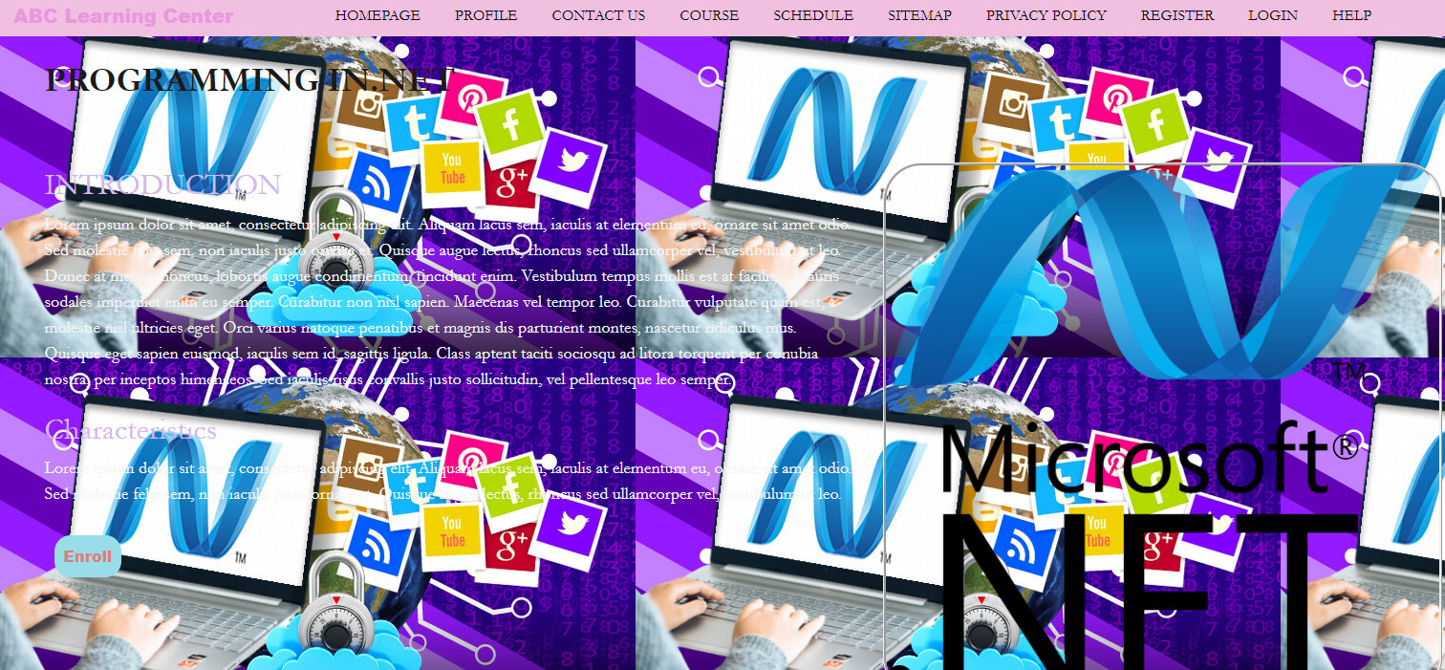

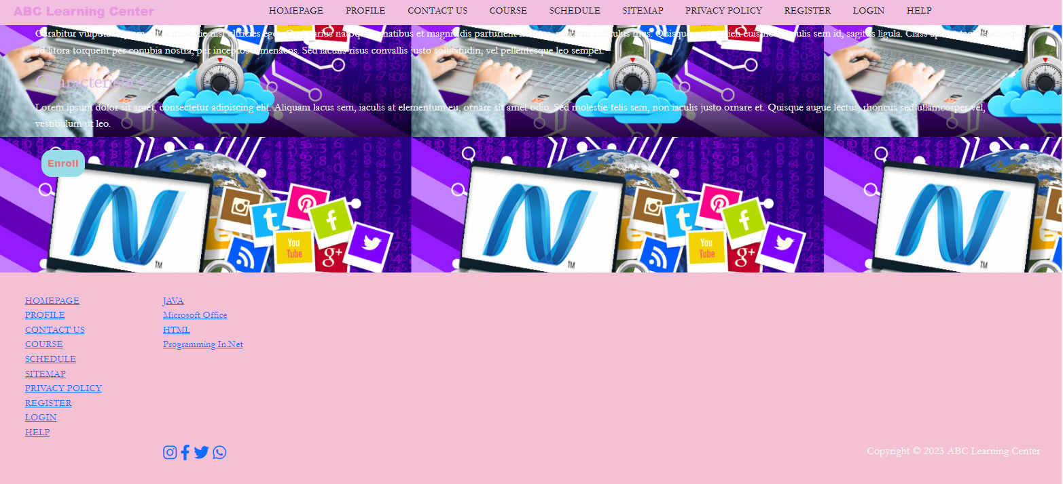

In the details of this course there are 4 pages with different details, the first page contains course details for java lessons, the second is microsoft, the third is HTML, and the last is programming In.Net, these four pages have more or less the same details, namely there is a course title, lessons description, program details such as a introduction,characteristic,logo of lessons,and videos to easy understanding. And enroll button schedule,etc.

6. about Schedule Page &detailed schedule page

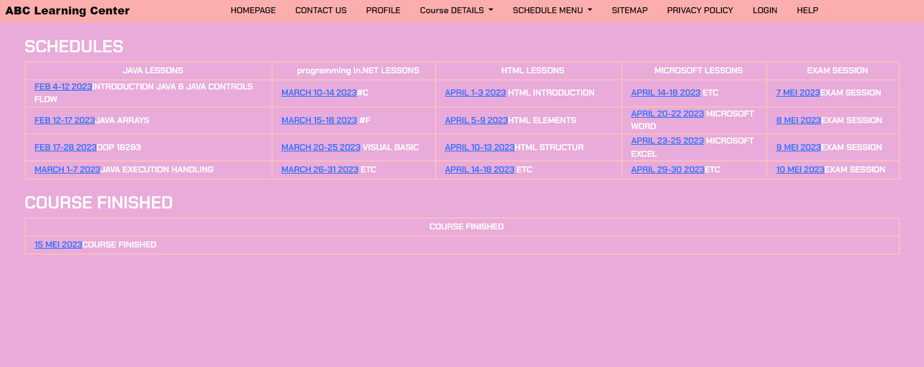

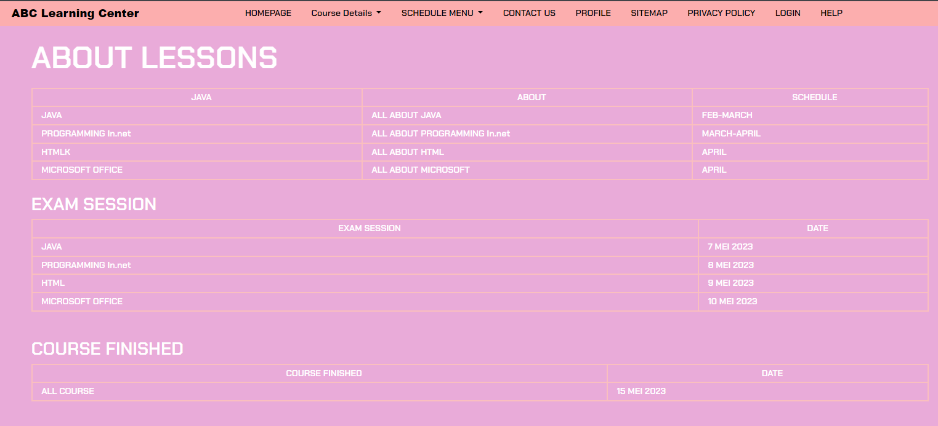

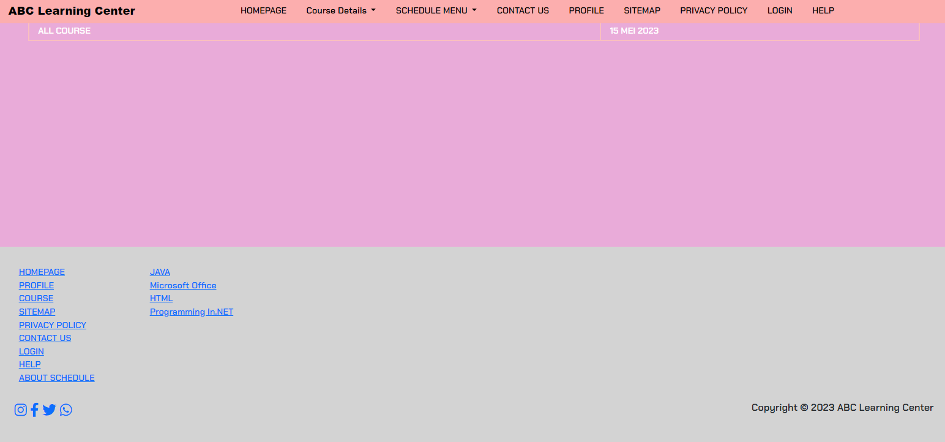

different from the course detail page in the previous point, here there are also 2 detailed schedules contains date & time for each course, and then exam session.and course finished.

7. Sitemap Page (Develop 1 HTML page)

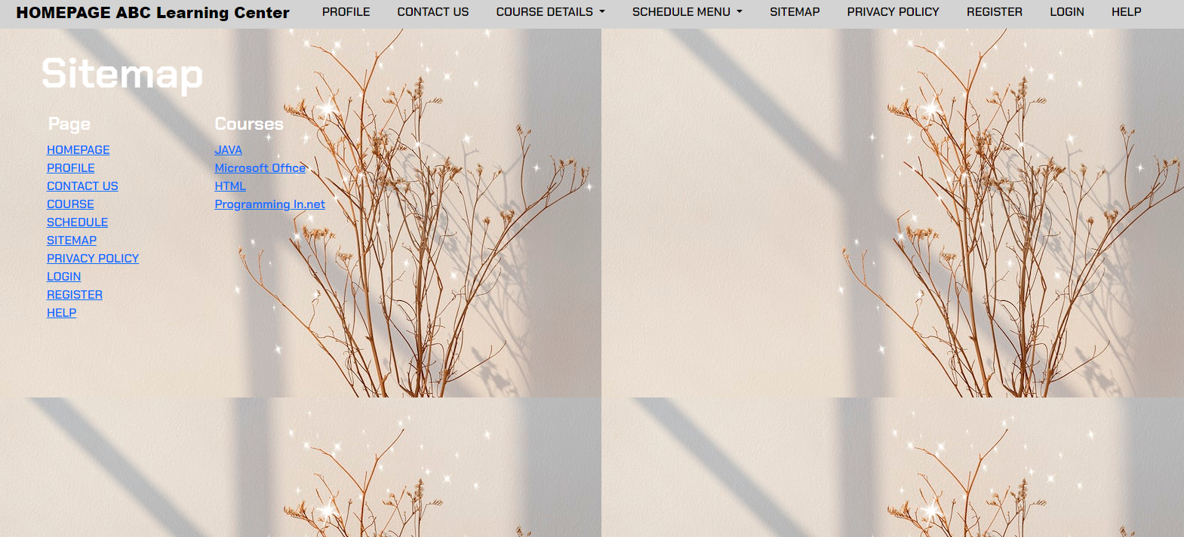

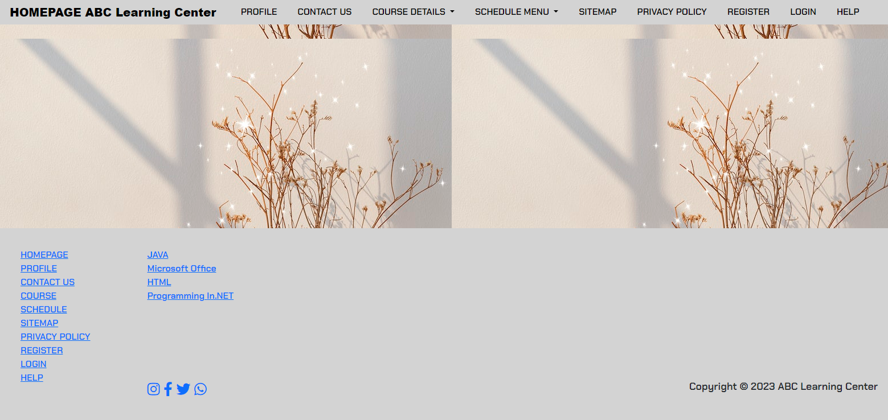

The sitemap page is a guide for all the pages on the website, on this website there are local homepages,profile,contact us,course,schedule,sitemap,privacy policy,register,login,help and detailed all courses. you can find many pages here which are presented with a list

8. Privacy Policy Page (Develop 1 HTML page)

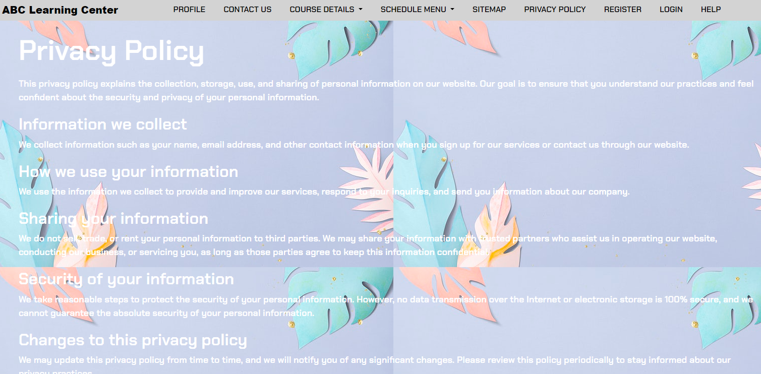

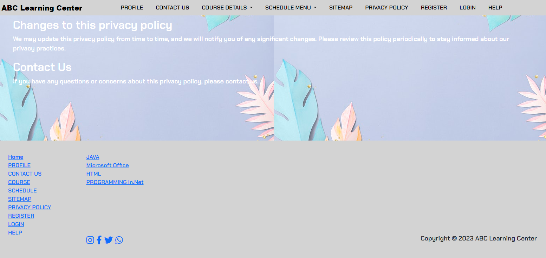

on this privacy & policy page there is only a provision that is on the website in detail and complete.

9.Register

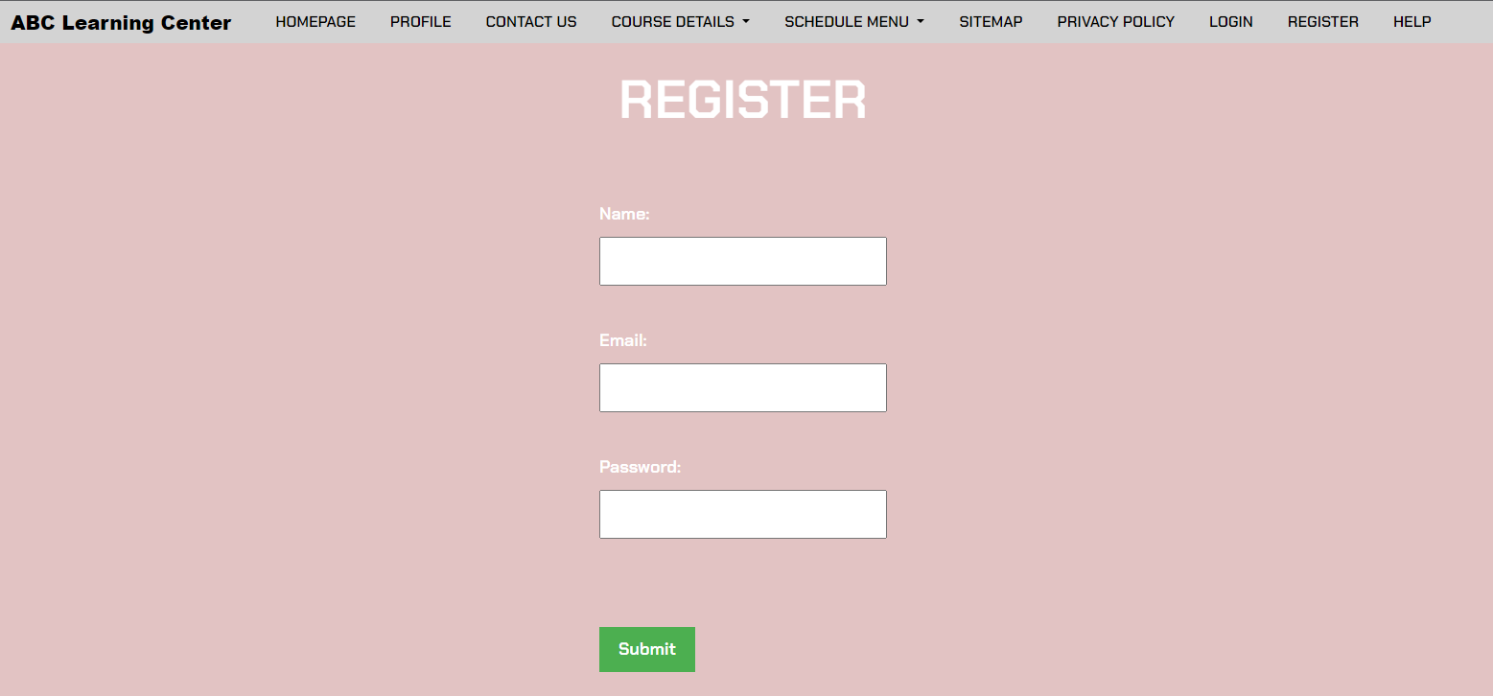

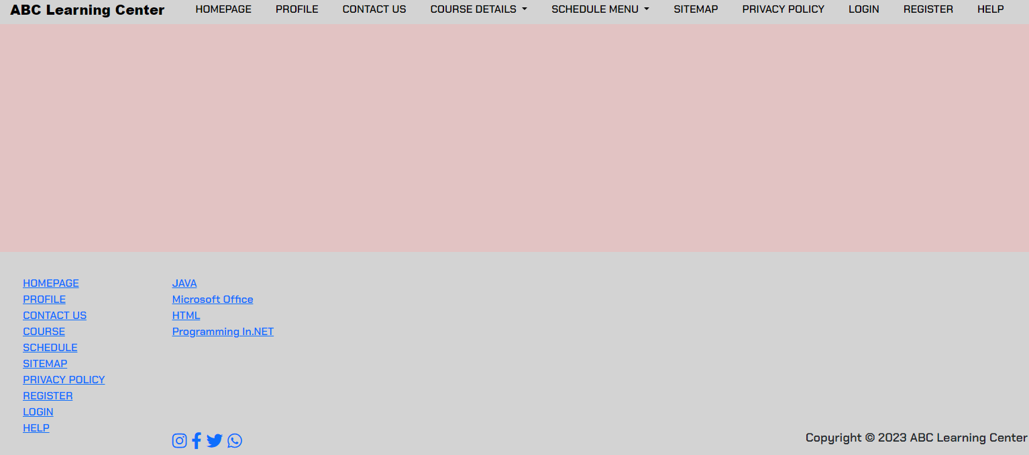

In this register page enables users and organizations to independently register and gain access to us system.

10.Login

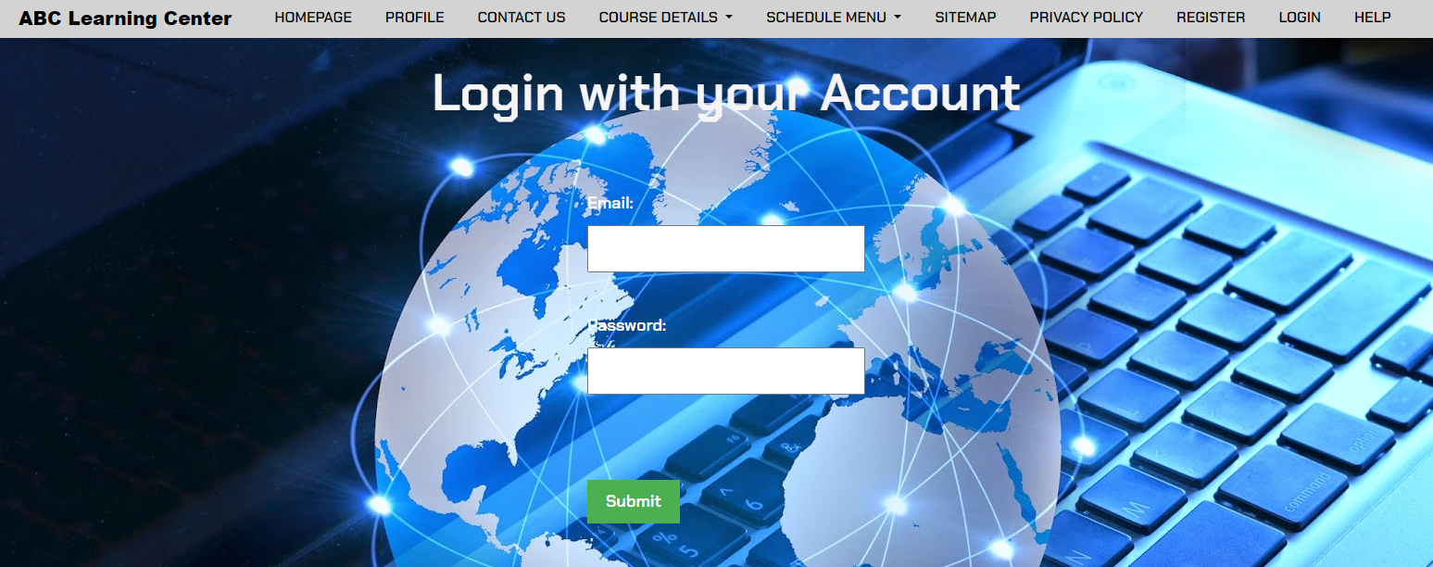

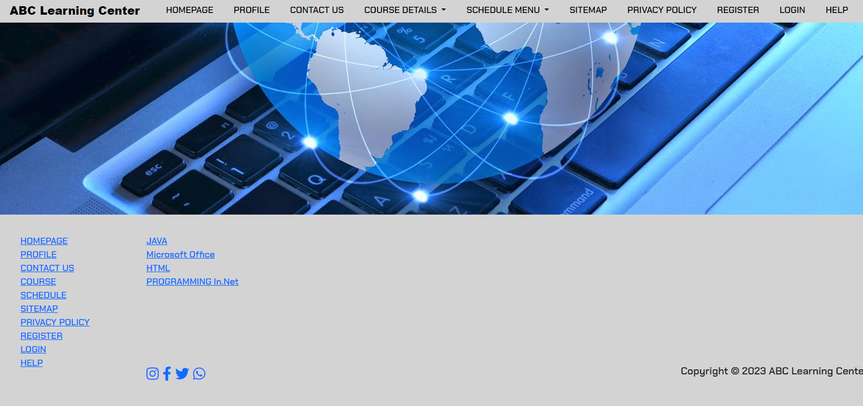

The login page allows a user to gain access to an application by entering their email and password.

11.course

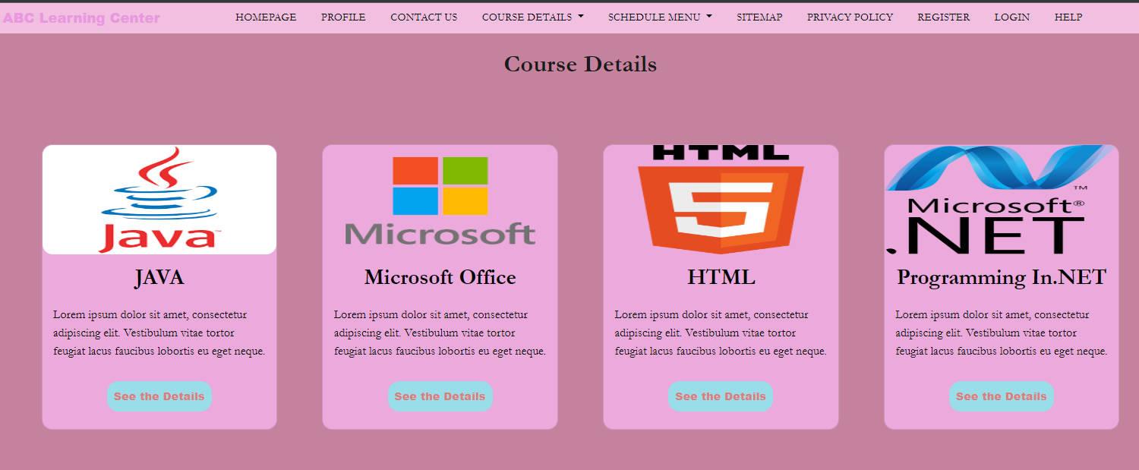

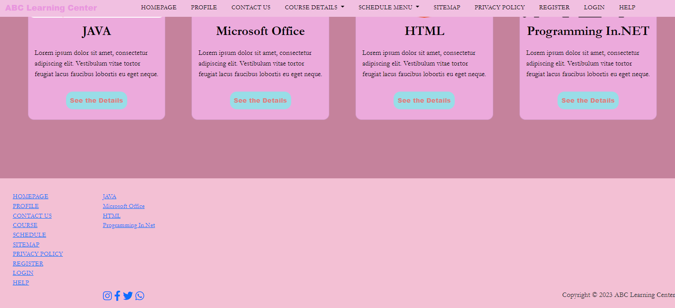

The course page area is navbar for the heading and four content of the course to easy access to each courses it self and more detailed of description.

**Testing and Validation**

The process of carrying out a variety of tests to verify the application's functionality, usability, and performance is referred to as testing in the context of web applications. This aids in the identification of any issues or errors that require resolution.

On the other hand, validation entails ensuring that the application's code complies with established standards and is error-free. This can be accomplished by checking for tags, attributes, forms, and HTML and CSS standards compliance.

In the process of developing a web application, both testing and validation are essential because they guarantee the application's high quality and dependability. The user experience is improved and costly downtime is avoided by early detection and resolution of issues. Additionally, the application's accessibility and compatibility with various devices and web browsers are ensured by code validation.

1. Usability

This involves testing the usability of the application, such as conducting user testing to determine how easy the application is to use.

|  |  |  |
| --- | --- | --- |
| No. | Actions | Test result |
| 1. | Check the tab should work properly. | Pass |
| 2. | Home link should be there on every single page. | Pass |
| 3. | Check for broken links and images. | Pass |
| 4. | Check the site on different resolutions (640 x 480, 600×800 etc.?) | Pass |
| 5. | All the buttons should be in a standard format and size. | Pass |
| 6. | Web page content should be correct without any spelling or grammatical errors. | Pass |
| 7. | All the fields should be properly aligned. | Pass |
| 8. | Title should display on each web page. | Pass |
| 9. | Verify that the website is secure and that users' personal information is protected. | Pass |
| 10. | Evaluate the readability of the text on the website and ensure that it is easy to understand and free from errors. | Pass |

1. Functional

Functional testing is a software testing approach that aims to assess the features and capabilities of a software application or system. The primary objective of this type of testing is to verify that the application performs as expected, adheres to its requirements and specifications, and functions properly.

|  |  |  |
| --- | --- | --- |
| No. | Actions | Test result |
| 1. | Test all the mandatory fields should be validated. | Pass |
| 2. | Test the functionality of the buttons available. | Pass |
| 3. | Verify that links are working correctly by clicking on each link and ensuring that the correct page is loaded. | Pass |
| 4. | Password with ***** output. | Pass |
| 5. | Email should be working with @email.com. | Pass |
| 6. | Test the Privacy Policy & FAQ is clearly defined and should be available for users. | Pass |
| 7. | Test the pop-up message (“This field is limited to 500 characters”) should display if the data reaches the maximum size of the field. | Fail |
| 8. | Test the max length of every field to ensure the data is not truncated. | Pass |
| 9. | Test if any functionality fails the user gets redirected to the custom error page. | Fail |
| 10. | Test all the uploaded documents are opened properly. | Pass |

1. Compatibility

Compatibility testing is a software testing technique that checks whether a software application is compatible with other system elements, such as browsers, operating systems, and hardware, to ensure that it can function properly within its intended environment.

|  |  |  |
| --- | --- | --- |
| No. | Actions | Test result |
| 1. | Test the website in different browsers (IE, Firefox, Chrome, Safari and Opera) and ensure the website is displaying properly. | Pass |
| 2. | Test the HTML version being used is compatible with appropriate browser versions. | Pass |
| 3. | Test the images display correctly in different browsers. | Pass |
| 4. | Test the fonts are usable in different browsers. | Pass |
| 5. | Test the web application on different mobile devices such as smartphones and tablets with various screen sizes and resolutions. | Pass |
| 6. | Test the web application with different security settings to ensure that the application functions properly with security software and settings. | Pass |
| 7. | Test the web application on different operating systems such as Windows, macOS, and Linux. | Pass |
| 8. | Testing the compatibility of a desktop application with different hardware configurations, including different processor types, memory sizes, and graphics cards. | Pass |
| 9. | Test the web application with different screen resolutions to ensure proper rendering on different devices. | Pass |
| 10. | Test the java script code is usable in different browsers. | Pass |

1. Performance

Performance testing is a type of software testing that is performed to assess how well a system or component meets certain performance requirements. This testing evaluates how well the system performs in terms of speed, scalability, stability, and other performance metrics, to ensure that it is functioning as expected and meets the desired performance criteria.

|  |  |  |
| --- | --- | --- |
| No. | Actions | Test result |
| 1. | Endurance testing the website to ensure that it can handle continuous use over an extended period of time. | Pass |
| 2. | Network latency testing to measure the impact of network delays on website performance. | Pass |
| 3. | Stress testing the website to determine how it performs under extreme load conditions. | Pass |
| 4. | Concurrency testing the website to determine how well it performs when multiple users are accessing the site simultaneously. | Pass |
| 5. | Browser compatibility testing to ensure that the website performs well on different web browsers. | Pass |
| 6. | Mobile device testing to ensure that the website is optimized for mobile devices and performs well on different screen sizes and resolutions. | Pass |
| 7. | Running the website under a sustained load to check for memory leaks or other issues that might cause the system to slow down or fail over time. | Pass |
| 8. | Testing the website's ability to scale up or down as needed to accommodate changing traffic patterns or other factors. | Pass |
| 9. | Simulating a large number of concurrent users accessing the website to ensure that it can handle the expected traffic without slowing down or crashing. | Pass |
| 10. | Comparing the performance of the website to industry standards or best practices to identify areas for improvement or optimization. | Pass |

1. Responsive

Performance testing is a type of software testing that is performed to assess how well a system or component meets certain performance requirements. This testing evaluates how well the system performs in terms of speed, scalability, stability, and other performance metrics, to ensure that it is functioning as expected and meets the desired performance criteria.

|  |  |  |
| --- | --- | --- |
| No. | Actions | Test result |
| 1. | Testing all features and functionality of a website or application is fully operational on all devices. | Pass |
| 2. | Verify that the website adjusts to different screen resolutions and does not require horizontal scrolling. | Pass |
| 3. | Verify that the website is optimized for touch screen devices and that all elements can be easily accessed and navigated with touch. | Pass |
| 4. | Verifying that a website or application loads quickly and performs well on all devices. | Pass |
| 5. | Testing that a website or application is accessible and user-friendly for users with disabilities on all devices. | Pass |
| 6. | Verify that the website's forms and input fields are easy to use and complete on different devices. | Pass |
| 7. | Verify that the website's navigation and menus are easily accessible and usable on all devices. | Fail |
| 8. | Verify that the website's text and font sizes are readable and legible on all devices, including small screens. | Pass |
| 9. | Verify that the website's images, videos, and other media are optimized for different devices and resolutions. | Pass |
| 10. | Verify that the website's layout and design are consistent across all devices and screen sizes. | Fail |